JENKINS – 02
- Configure 2 slave machines in the Jenkins master.
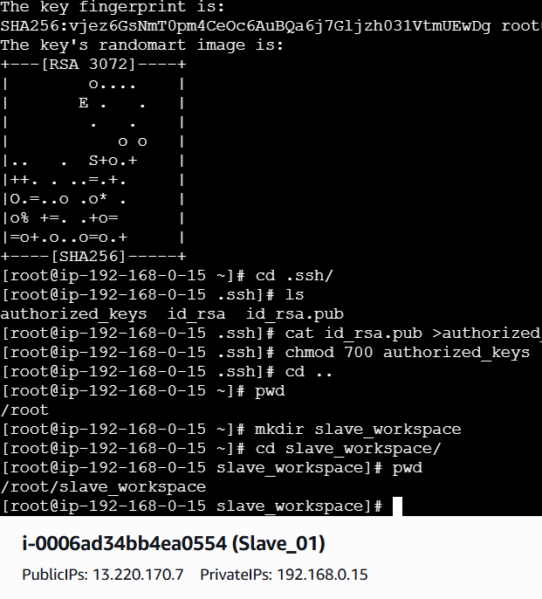
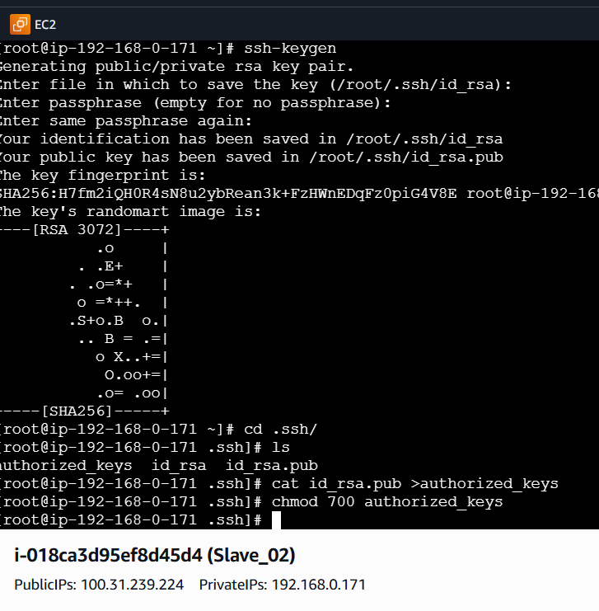
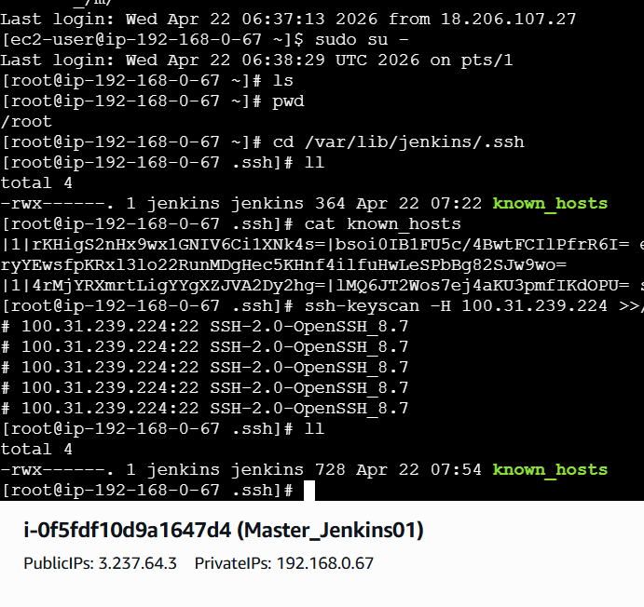
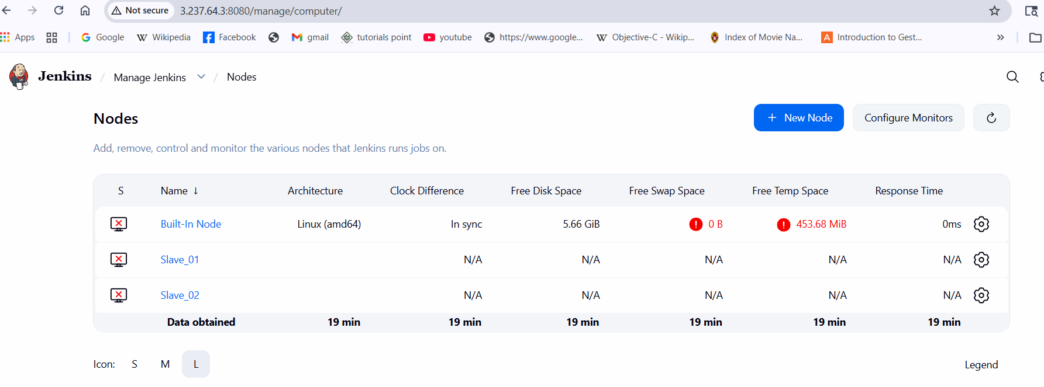
2. Configure webhooks to the Jenkins job.
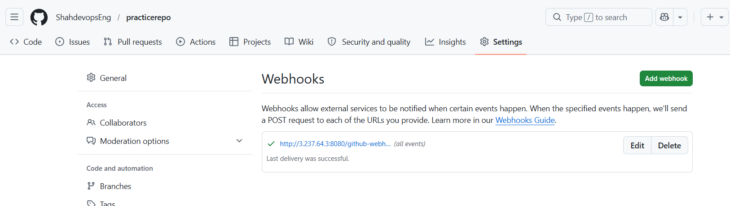
3. Configure Poll SCM and Build Periodically options in the Jenkins job.
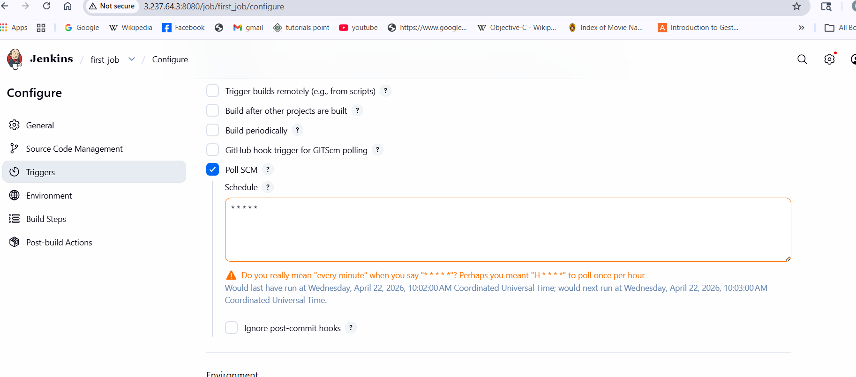
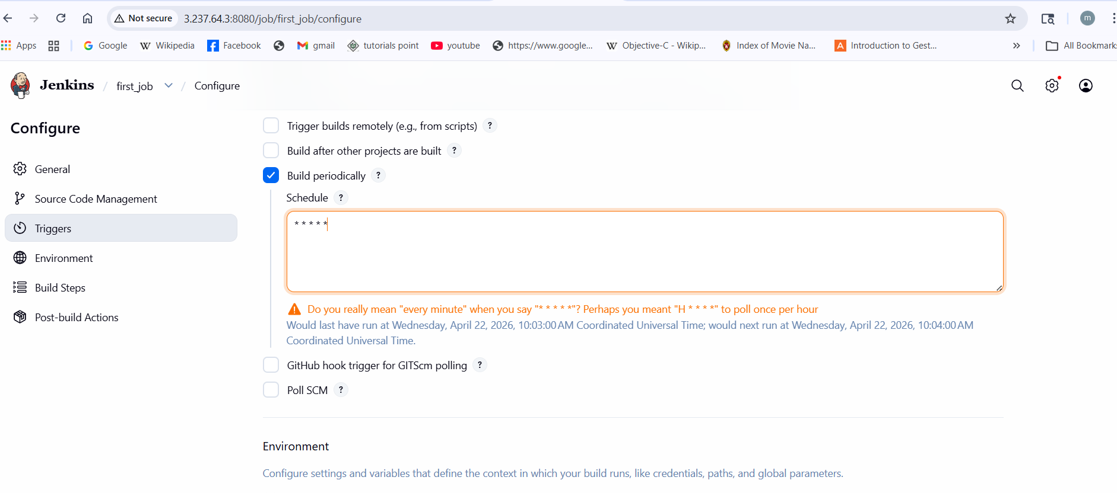
4. Take a backup of the Jenkins server using a bash-script.
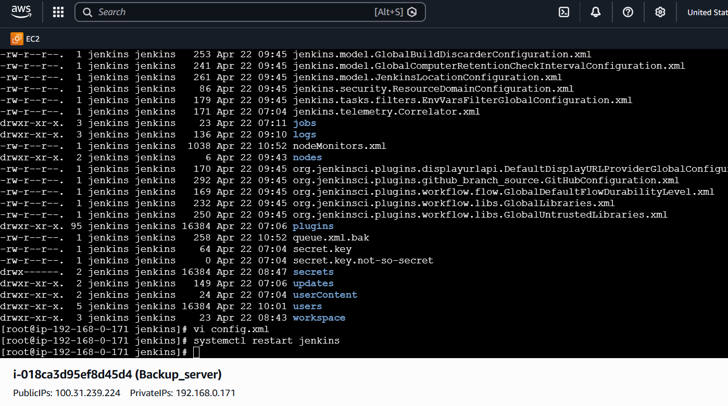
5. Take a backup of Jenkins using the ThinBackup plugin.
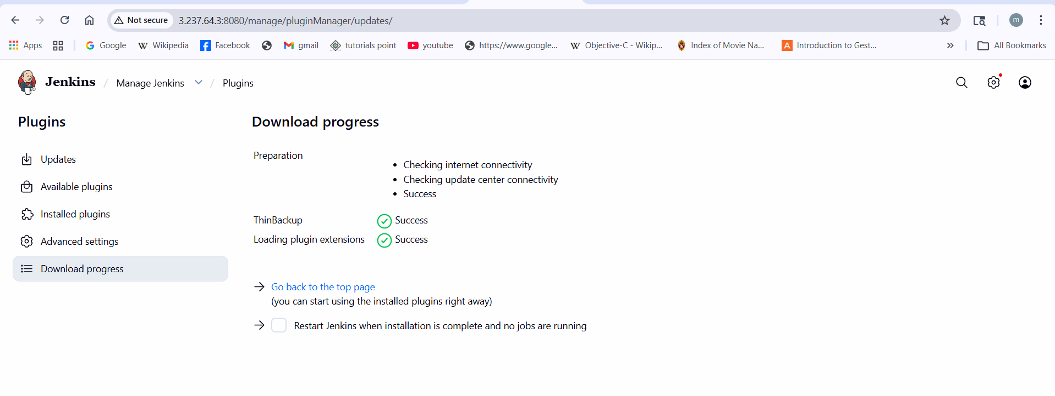
6. Set up a new Jenkins server and restore the backup ta ken in task 4.
